**Experiment 9**

**Aim: Assembly program to find Factorial of a number**

**Part A: Factorial without macros.**

**Code:**

DATA SEGMENT

N1 DW 05H

FACT DW ?

DATA ENDS

CODE SEGMENT

START: MOV AX, DATA

MOV DS, AX

MOV AX, N1

L1: DEC N1

MUL N1

MOV CX, N1

CMP CX, 01H

JNZ L1

MOV FACT, AX

CODE ENDS

END START

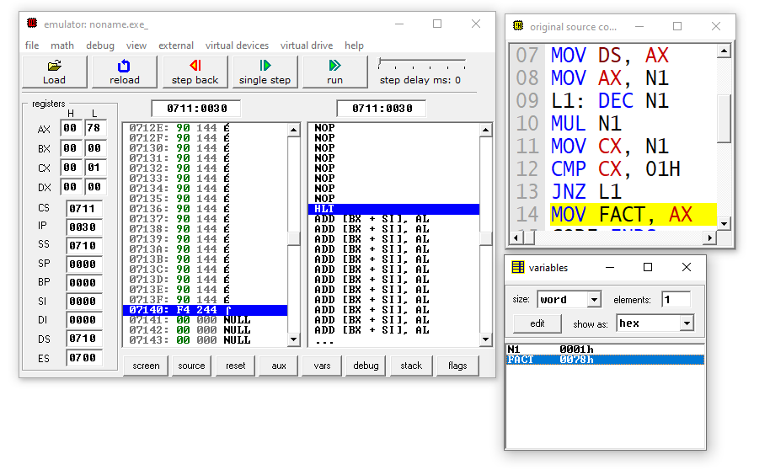

**Part B: Factorial with macros.**

**Code:**

FACT MACRO F

UP:

MUL F

DEC F

JNZ UP

ENDM

DATA SEGMENT

NUM DW 05H

RESULT DW ?

ENDS

CODE SEGMENT

START:

MOV AX,DATA

MOV DS,AX

MOV CX,NUM

MOV AX, 0001H

FACT NUM

MOV RESULT,AX

ENDS

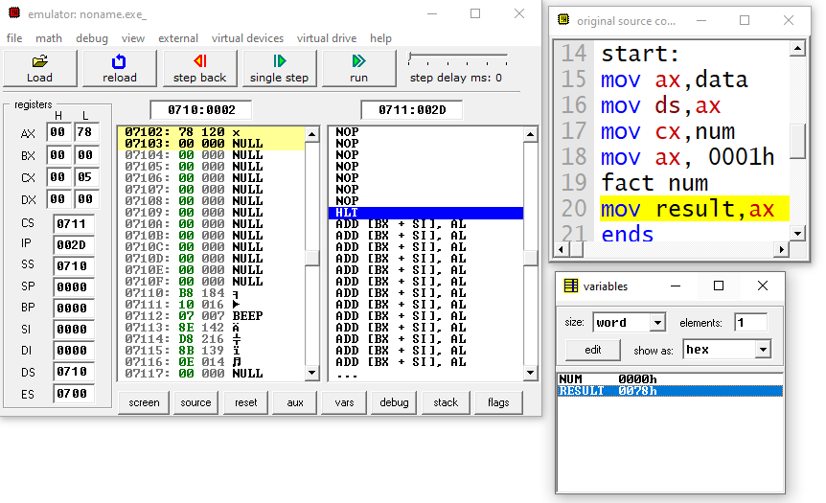END START